1. write a java Program to print smallest and biggest possible palindrome word in a given string

public class Main

{

    public static boolean isPalindrome(String a){

        boolean flag = true;

for(int i = 0; i < a.length()/2; i++){

            if(a.charAt(i) != a.charAt(a.length()-i-1)){

                flag = false;

                break;

            }

        }

        return flag;

    }

    public static void main(String[] args){

        String string = "Wow you own kayak";

        String word = "", smallPalin = "", bigPalin="";

        String[] words = new String[100];

        int temp = 0, count = 0;

        string = string.toLowerCase();

        string = string + " ";

        for(int i = 0; i < string.length(); i++){

            if(string.charAt(i) != ' '){

                word = word + string.charAt(i);

            }

            else{

                words[temp] = word;

                temp++;

                word = "";

            }

        }

        for(int i = 0; i< temp; i++){

            if(isPalindrome(words[i])){

                count++;

                if(count == 1)

                    smallPalin = bigPalin = words[i];

                else{

                    if(smallPalin.length() > words[i].length())

                        smallPalin = words[i];

                    if(bigPalin.length() < words[i].length())

                        bigPalin = words[i];

                }

            }

        }

        if(count == 0)

            System.out.println("No palindrome is present in the given string");

        else{

            System.out.println("Smallest palindromic word: " + smallPalin);

            System.out.println("Biggest palindromic word: " + bigPalin);

        }

    }

}

Output:

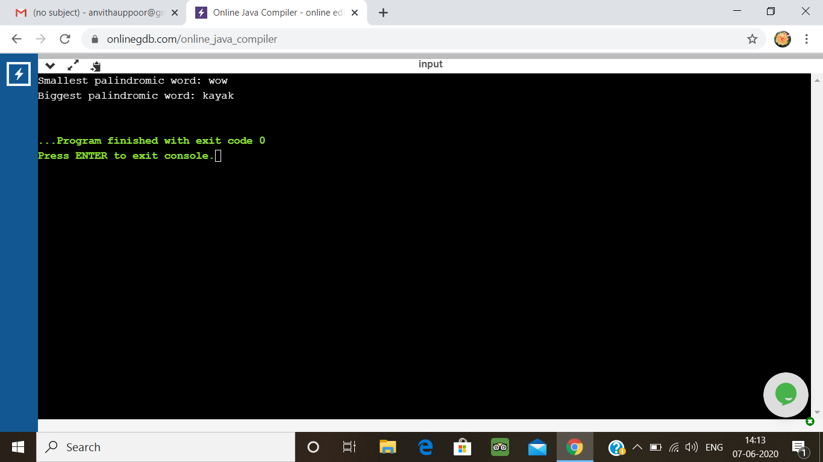

2. Write a Java Program to remove all white spaces from a string without using replace()

public class Main {

public static void main(String[] args) {

String str = "My Name is Anvitha ";

char[] strArray = str.toCharArray();

StringBuffer stringBuffer = new StringBuffer();

for (int i = 0; i < strArray.length; i++) {

if ((strArray[i] != ' ') && (strArray[i] != '\t')) {

stringBuffer.append(strArray[i]);

}

}

String noSpaceStr2 = stringBuffer.toString();

System.out.println(noSpaceStr2);

}

}

**Output:**

